**Mr. Visca’s: Calculus (Chpt 3.1)**

**Chpt 3 – Day 1 Derivatives of Functions**

3.1 Derivative of a function

Definition:



Alternative Definition:

*the derivative of the function f at the point x = a, is the limit*



Notation:

* y’:
* f’(x):

$\frac{dy}{dx}$

$\frac{d}{dx}f(x)$

Example: Find the derivative of *f(x)* = *x*3 Example: Differentiate $f\left(x\right)=\sqrt{x}$ at *x* = a.

One Sided Derivatives

$$y=\left\{\begin{aligned}x^{2} x≤0 \\ 2x x>0\end{aligned}\right.$$

Left hand derivative at x=0

Right hand derivative at x=0

The function _____________________ have a derivative at x=0.

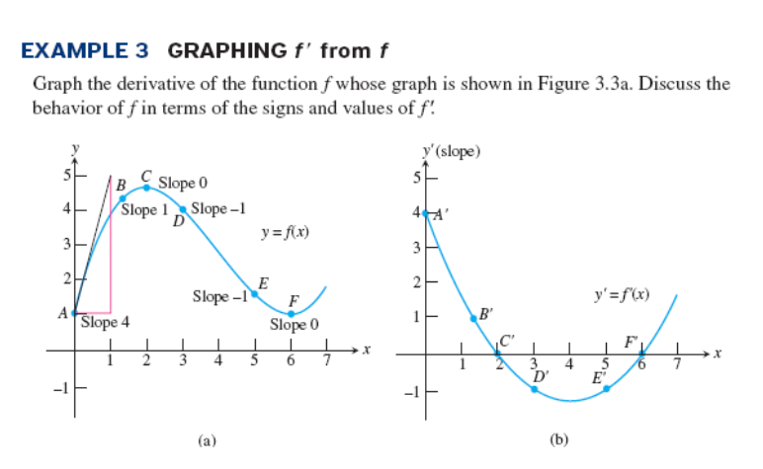The function is _____________________________ at x=0.

HW: Section 3.1

(1, 2, 5, 8, 10, 12, 13-18, 21, 27, 42)